Knowledgebase 1017: MS365 - Configuring MS365 on a new Outlook Profile
9 simple steps to set up your new MS365 outlook profile
- Go to Control Panel and open the Mail App | 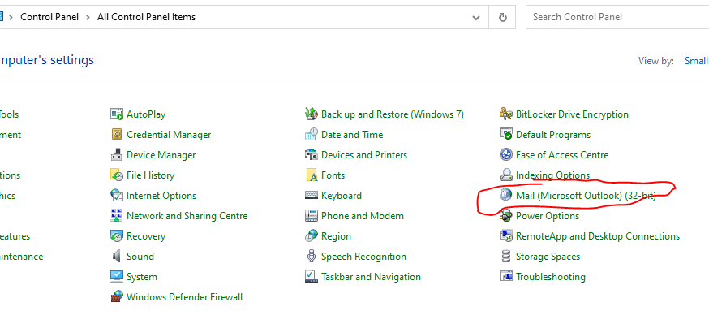
- Click on Show Profiles | 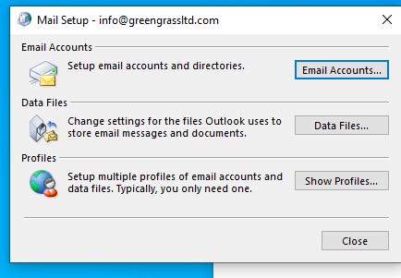
- Make sure the option is set to prompt for a profile to be used and create a new name for your profile that makes it clear its your new MS365 mailbox  And click Ok | 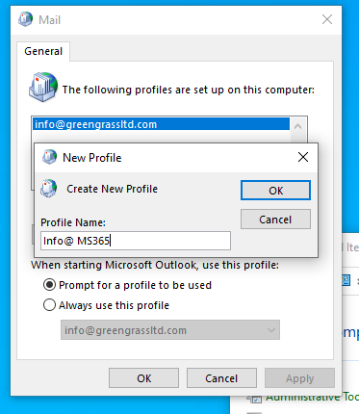
- Enter the name of the mailbox, email address and password (twice)  And click next | 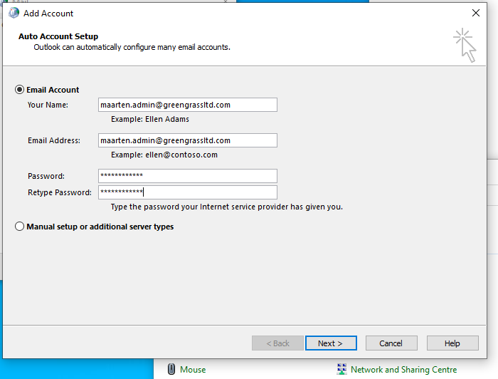
- When prompted – login to MS online with your email address and new password | 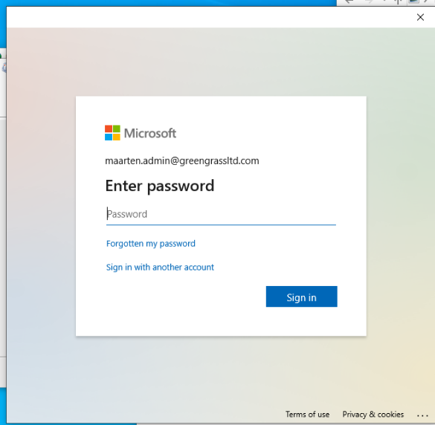
- Authenticate your login with the authenticator app on the phone ( enter the pin shown) | 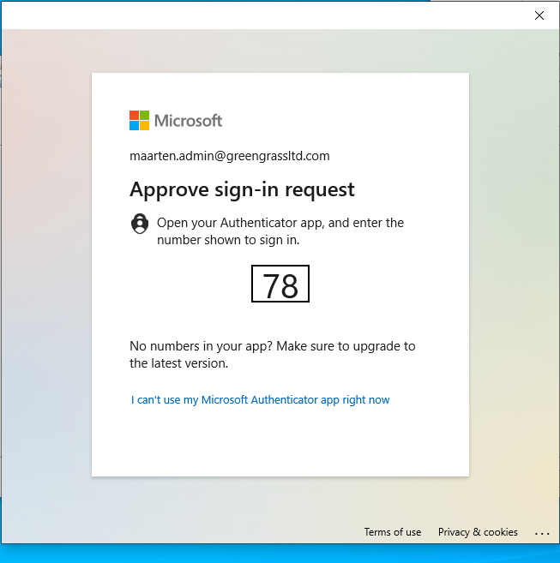
- Your account is set up – click Finish to close the window | 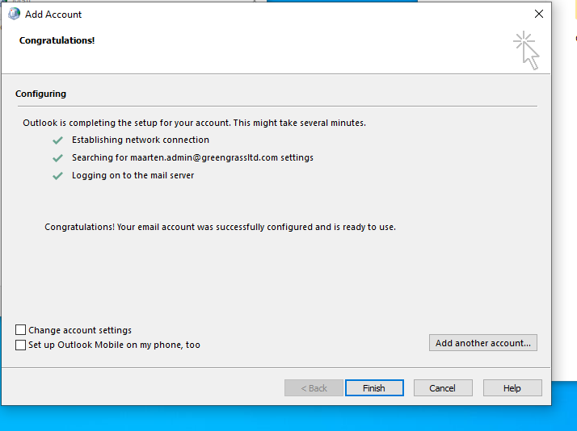
- You should now see two profiles your old mailbox and your new MS365 mailbox is now set up  Click Ok to close | 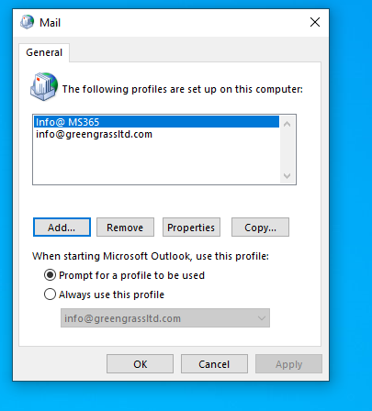
- Open Outlook and select the new MS365 profile in the dropdown to send and receive emails. | 